#MVA:

http://dot.net/

https://dotnet.microsoft.com/learn/web/aspnet-hello-world-tutorial/create

dotnet --version

where dotnet

dotnet --help

dotnet new

dotnet new console --help

dotnet new console

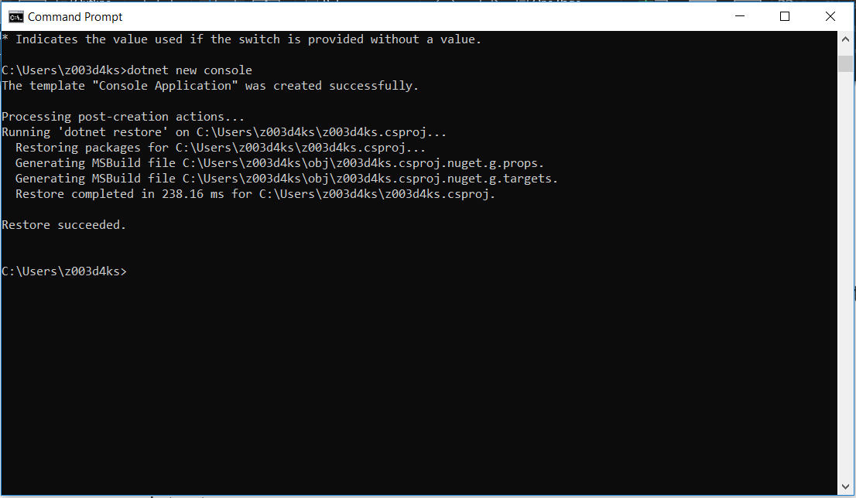

Type practice.csproj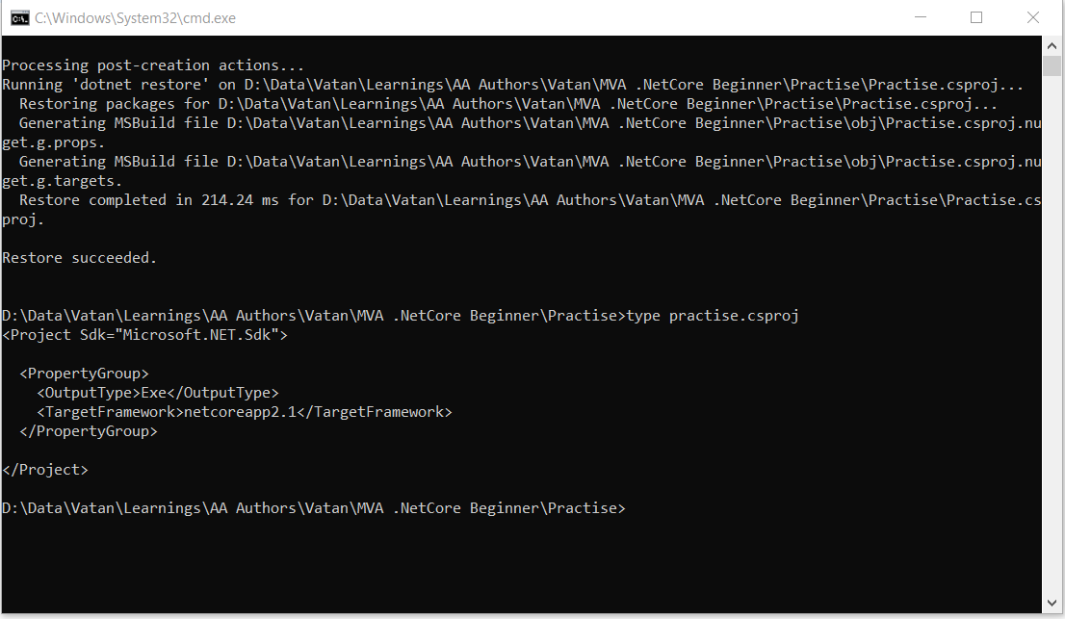

type program.cs

dotnet run

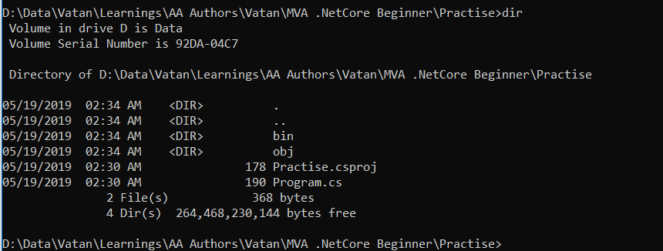

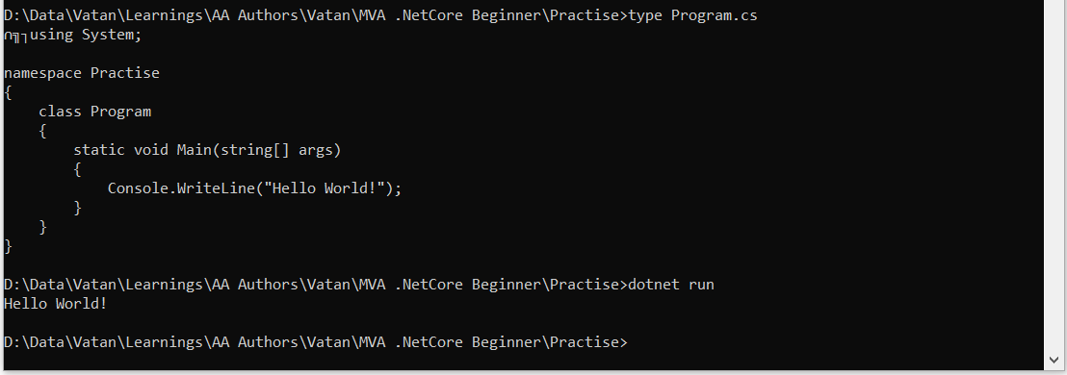

Open vs code

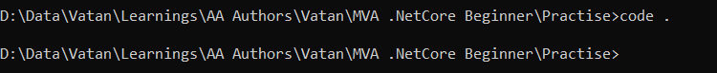

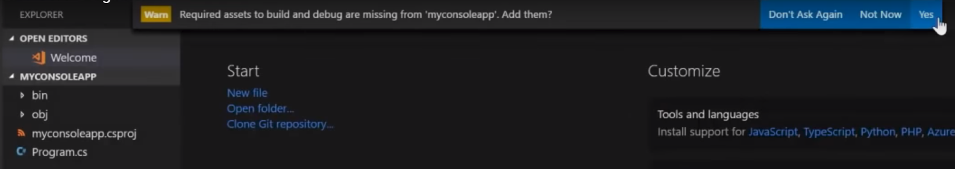

Added .vscode here.

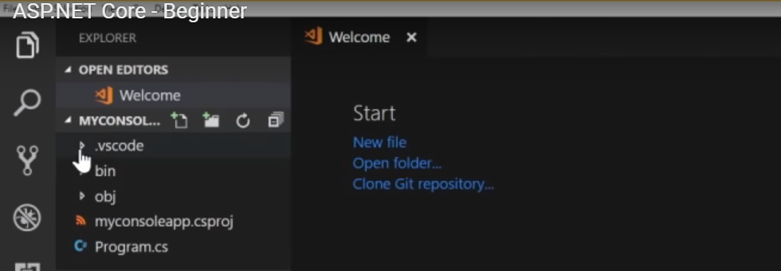

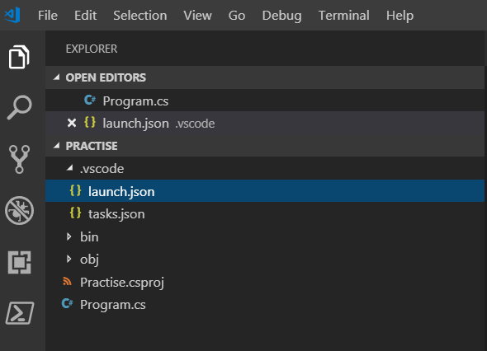

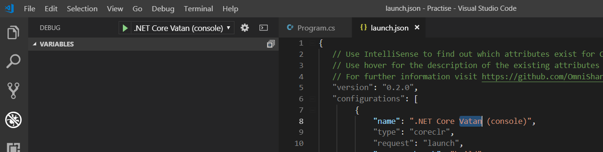

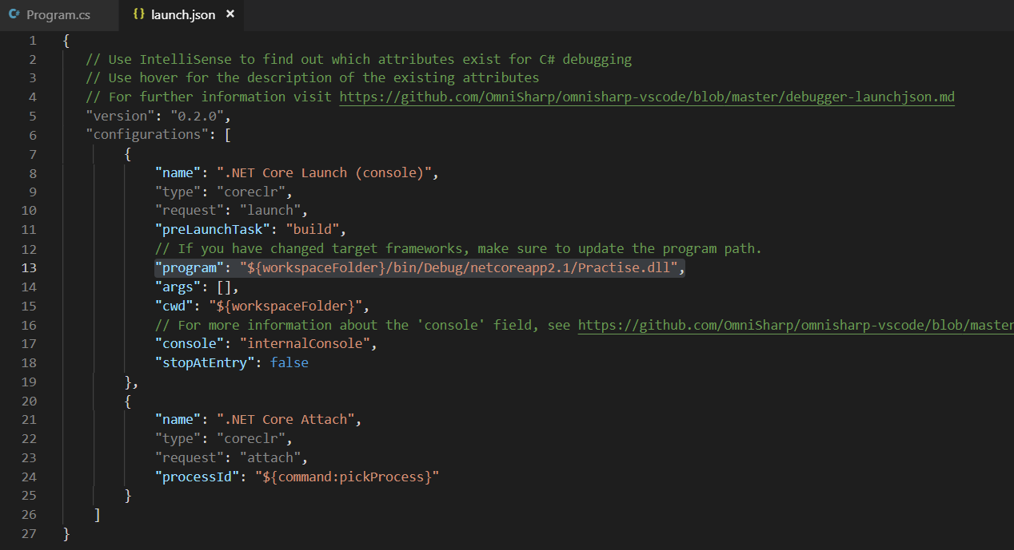

On dotnet run it finds program property and run it of launch.json (as above).



Creating Web app:

Dotnet new webapp -o mywebapp

It creates a folder mywebapp and put the application mywebapp there.

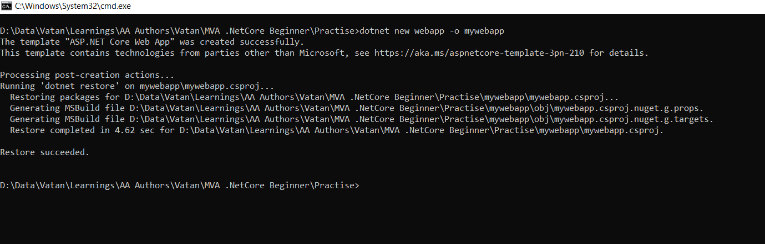

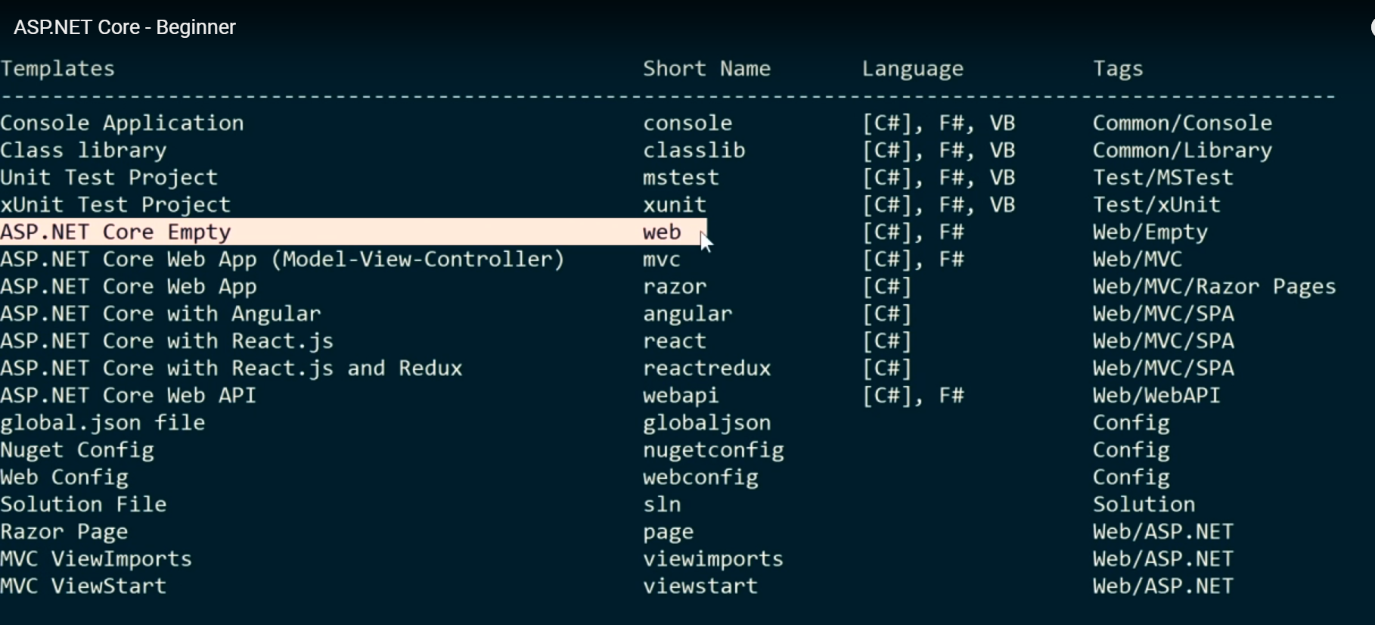

Removed some default code:

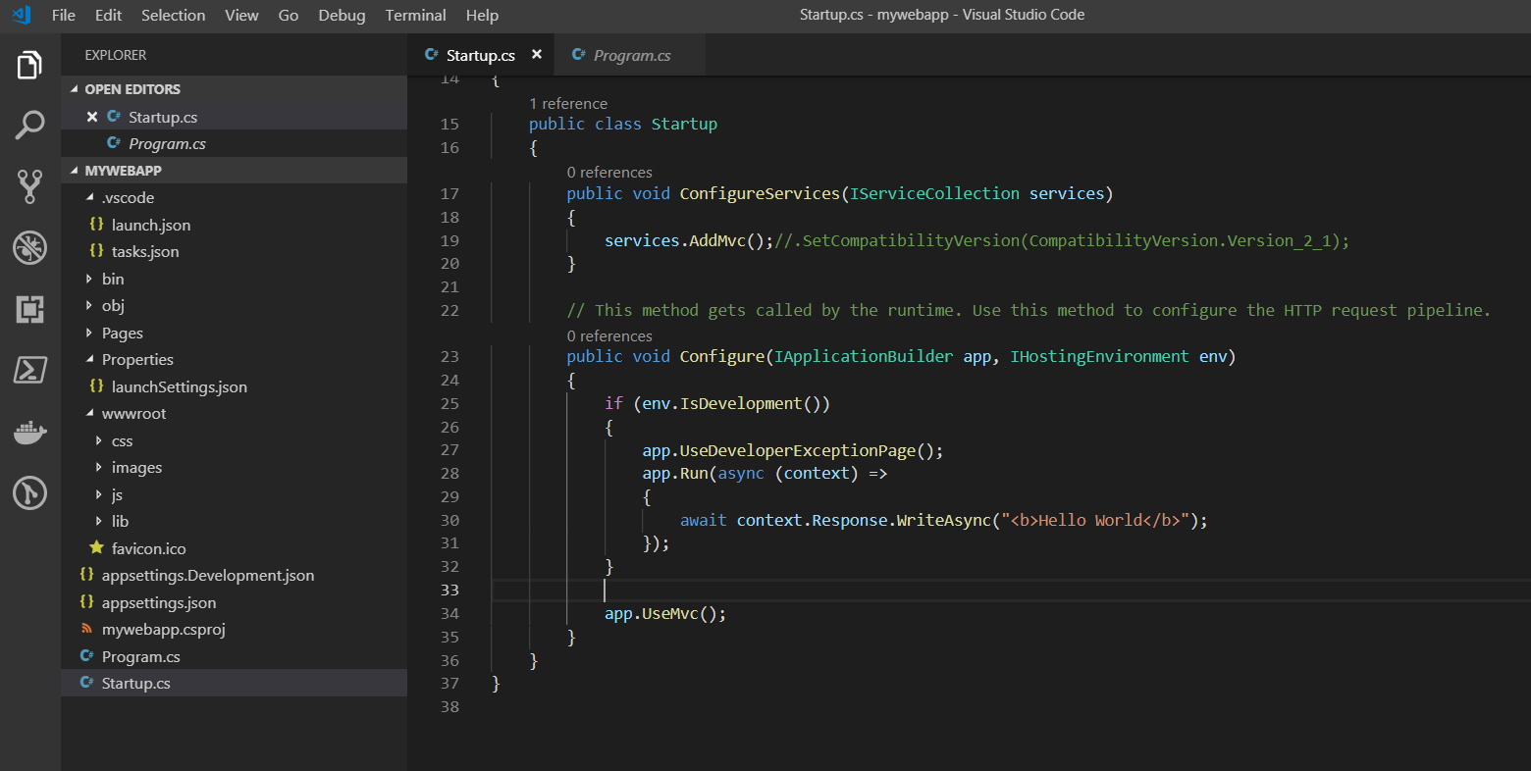

App.UseMvc() : it includes default redirect logic (like by default go to Index.cshtml)

Index is by default taken:

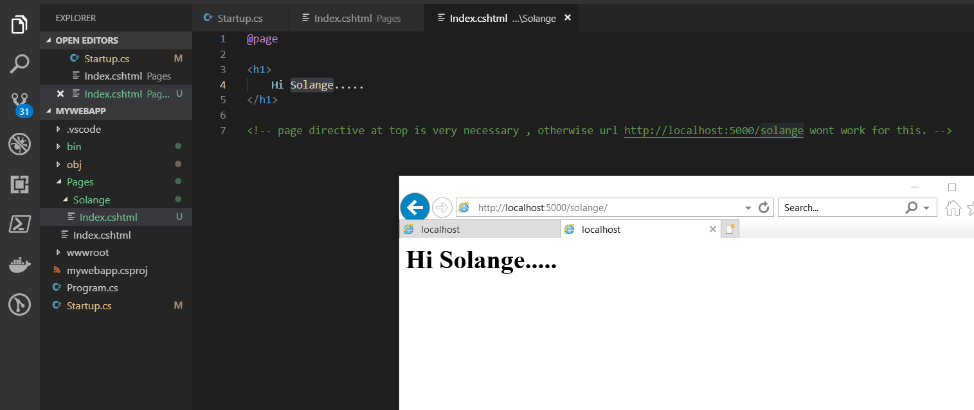

Solance need to be given in url:

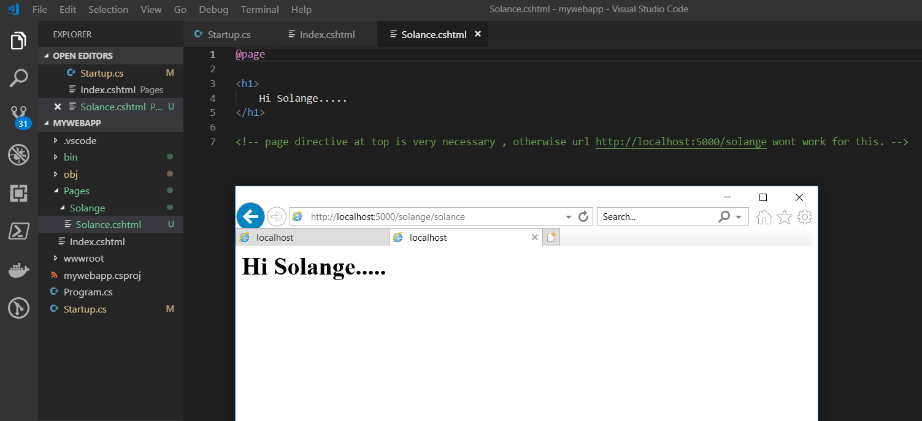

No need to build again on change in Razor pages.

**From Visual studio default templates:**

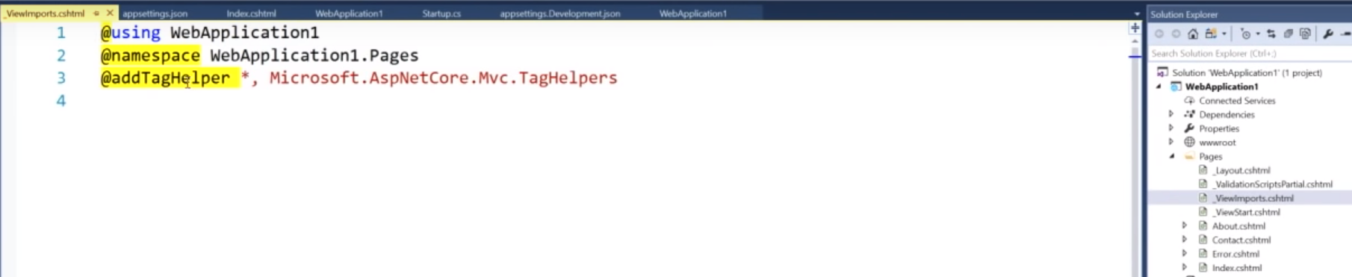

1. _ViewImports.cshtml:

All of the things we want to every page to have.

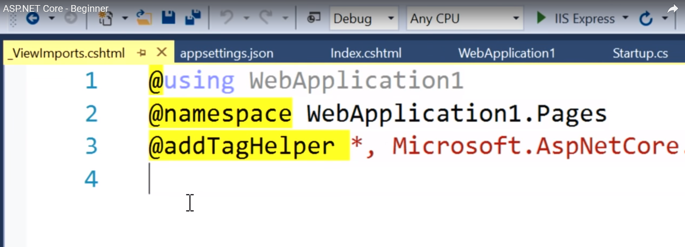

1. _ViewStart.cshtml: Runs for every view.
2. _Layout.cshtml : have hader footer etc and other views render inside **@RenderBody()**